**GETTING STARTED WITH RSTUDIO**

**Prepare your code directory:**

Log into the UCL machine.

Create a folder in your N: drive called RProjects

In this folder create a folder called Day1

Download the file **install_all_packages.R** and copy this into the directory you created.

**Open RStudio**

Find application **RStudio 1.1.456** (some UCL machines have two versions installed).

In the Files panel: click the three dots icon. This lets you browser to a directory on your computer:

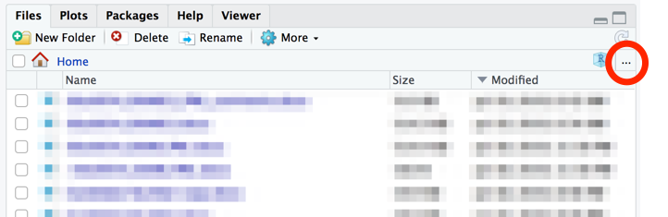

Browse to your N:/RProjects/Day1 folder.

In the "More" menu click "Set As Working Directory". This means R will look in the Day1 directory when asked to open/save files by default.

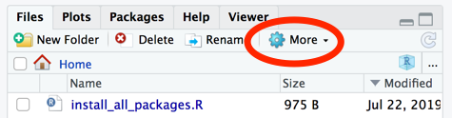

Click on "install_all_packages.R" this should open the file in the editor panel.

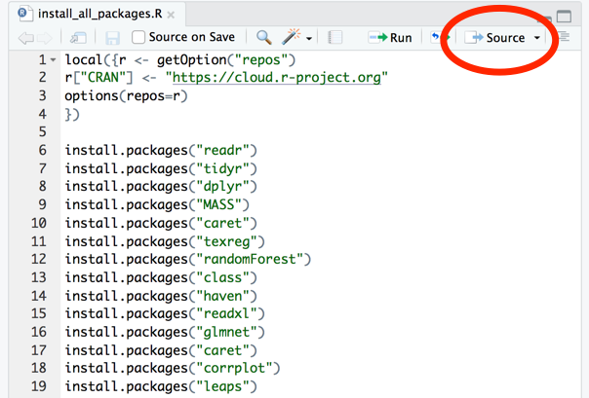

Click "Source" to run all the code in the file. You should see the libraries installing in the console panel. This may take some time… Be patient!

If you have a laptop you can then repeat the procedure on it to install the required libraries. (Create the RProject directory in your home or documents area).